Budget Rent A Car 
of British Columbia

Global Information System

Maestro Reports Business Design

Version 2.00

Note: The information contained in this document is confidential and may not be disclosed to any parties outside of Budget Rent a Car of British Columbia without written consent by one of its officers.
Copyright (C) 2000 Budget Rent a Car of British Columbia

TABLE OF CONTENTS

1. REPORT SPECIFICATIONS 1
1.1 Maestro Reservation Error Report 1
1.2 Batch Run Log Report 4
2. Revision History 8
2.1 Version 2.00 8

Appendix A. Parameter Screen Layouts

1. REPORT SPECIFICATIONS

1.1 Maestro Reservation Error Report

Purpose
This report is used to list errors/warnings encountered when updating the GIS database with Maestro reservation information, to allow Budget BC to take corrective action where appropriate.

Parameters

Name | Description
Begin Date and Time | Batch Start Date should be greater or equal to this.  Past or current date.
End Date and Time | Batch Start Date should be smaller or equal to this.  Must be greater than the Begin Date and Time.
Error Level | 1/All  Current values:  - Warning  - Information  - Error  (Drop down box)
Type | Current values:  - System  - User  (Implemented as two check boxes on the parameter screen, both can be checked)

Running of Report and Distribution
- This is an on request report.
- This report will be used by the following user groups: Executive, Admin & Customer Service and Revenue Management.
- This report will typically be run 1 or 2 times a day.
- Assuming there are only a few errors each day, the size of this report will typically be 2 to 4 pages.

Report Layout
- Group by:
  - Batch Start Date (sorted in ascending order)
- Sorting sequence:
  - Process Date and Time (in ascending order).
- Report fields are defined by the Sample Layout

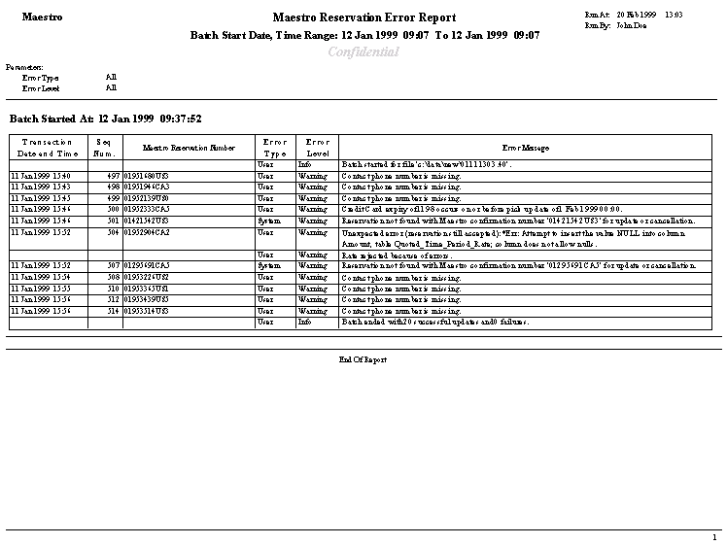Sample Layout

1.2 Batch Run Log Report

Purpose
This report is to list the batch process runs that have occurred during a given period. Each batch process outputs messages with the start and end time of each run (or in some cases for each set of data processed by the run e.g. Maestro Interface) and control totals (e.g. number of records processed by the run). It will be used by Systems Staff to monitor batch processes and assist in resolving problems related to batch process runs.

Parameters

Name | Description
Begin Date and Time | Batch Start Date should be greater or equal to this.  Past or current date.
End Date and Time | Batch Start Date should be smaller or equal to this.  Must be greater than Begin Date and Time.
Process Code | 1/All Codes (Excl. Maestro)/All Codes (Incl. Maestro)  (Drop down box)  e.g. Maestro, No Show, Interim Bill  If the option All Codes (Excl. Maestro) or all Codes (Incl. Maestro), this parameter will be set to ALL and is not selectable.
Error Level | 1/All  Current values:  - Warning  - Information  - Error  (Drop down box)
Type | Current values:  - System  - User  (Implemented as two check boxes on the parameter screen, both can be checked)

Running of Report and Distribution
- This is an on request report.

- This report will be used by the following user groups: Executive, Admin & Customer Service and Revenue Management.
- This report will typically be run 1 to 2 times per day.
- The size of this report will typically be 5 to 6 pages.

Report Layout
- Group by:
  - Batch Start date (sort in ascending order, add extra line between groups)
  - Process Code (sort in ascending order, add extra line between groups)
- Sorting sequence:
  - Process Date and Time (sort in ascending order)

Sample Layout

2. Revision History

2.1 Version 2.00
- Clean up documentation and make consistent with the GIS standards.

